**Formatting Date of Birth in the Students File**

1. Right click on the “date_of_birth” column in your “students” file and select **Format Cells**:

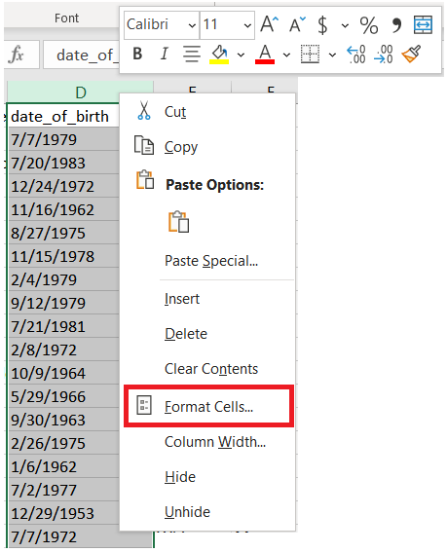

1. In the **Format Cells**box, click the **Number** tab.
2. In the **Category** list, click ***Date.***

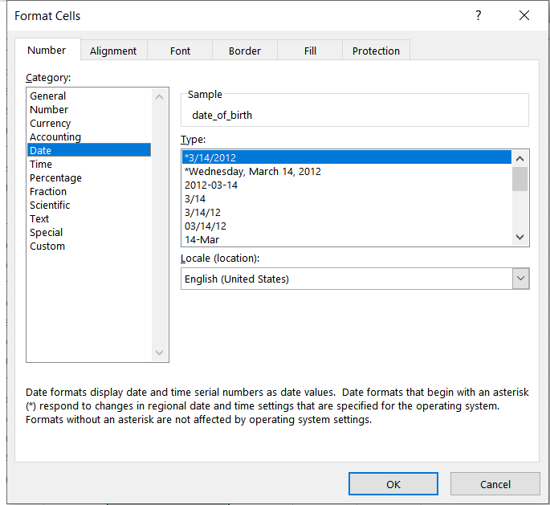

1. Under **Type** select *3/14/2012.
2. Go back to the **Category** list and choose **Custom**. Under **Type**, you will see the format code for the date format you chose in the previous step.

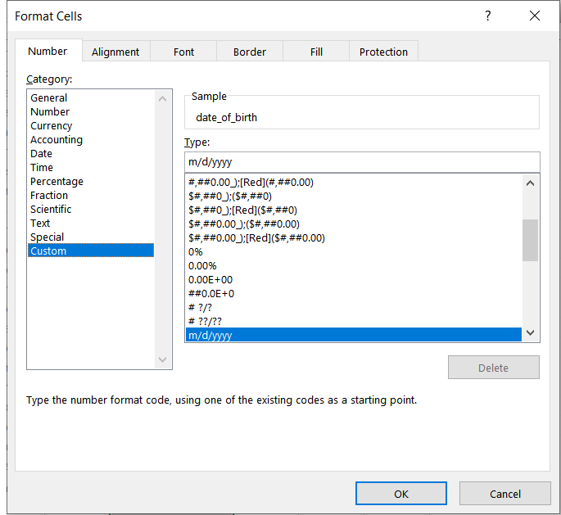

1. In the **Type** box above the list, change he format to dd/yyyy.

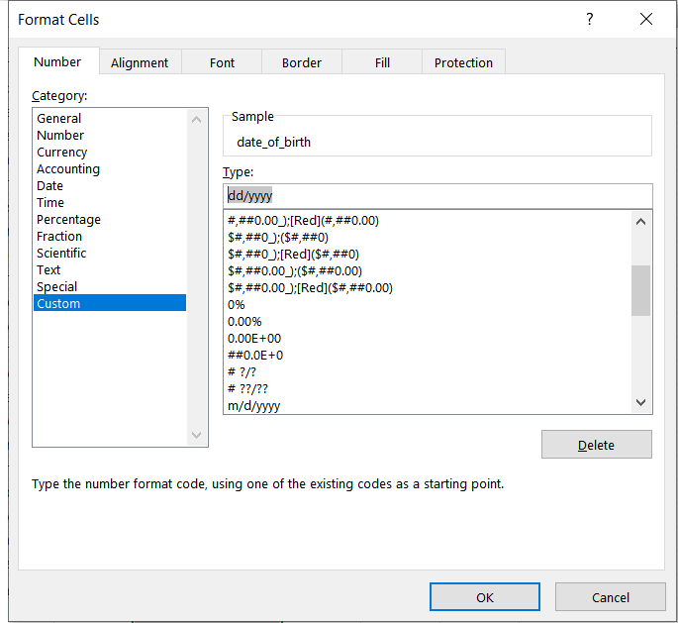

1. Hit the “OK” button.
2. Your “date_of_birth” column will display dates with the dd/yyyy format.